The Naylor Model
Finding base-stealing skill that sprint speed hides · for MLB R&D and coaching staffs
BOTTOM LINE Some of the best base-stealers in baseball are among its slowest. This report measures the skill speed hides, prices each skill in steals, and names who to coach in 2025.
Named for its clearest example: in 2025 Josh Naylor stole 30 bases at 92% while slower than 98% of MLB — the top steal-skill season in our 673. But the subject is the quality, not the player: a quick jump, an explosive secondary lead, and reading the pitcher early. Unlike foot speed, all three are coachable — and found league-wide. Four pages: (1) what each skill is worth, (2) who already has it, (3) who to coach in 2025, (4) the drills.
READING THE NUMBERS
Everything is in steals. Each skill's payoff is the extra stolen bases it adds over a 20-attempt season. The top skill is worth about +5 steals.
Colors rank within a table. Green = best shown, red = worst shown (can still beat the MLB average), gold = the Naylor/Soto archetype. Charts use no red — everyone shown is already elite.
What it's for. Who to develop and what to drill — not calling any single steal (model accuracy is in the Appendix).

If you read nothing else: the three levers that move a steal
The 80/20 — coach these, in order of payoff
+5 steals / 20 tries Ground covered after the pitcher commits.
+3 steals / 20 tries Jump — quickness over the first 30 ft.
+2 steals / 20 tries First-step quickness vs. top speed.

All three are technique, not body type — which is why a slow runner can lead the league in steal skill. Section 1 prices them in full; Section 4 turns them into drills.

1 What Each Skill Is Worth — in Steals
What we did. We fit a model on Statcast runner-seasons that isolates how much each skill changes the chance of a successful steal, then priced every skill in the only unit that matters to a coach: extra stolen bases from one realistic, off-season-sized improvement.
BOTTOM LINE Three trainable skills dominate — covering ground after the pitcher commits, a quicker jump, and reaching top speed sooner. Raw foot speed barely moves the needle.
Variables in this view:
- Coachable lever — A trainable skill the model links to stolen-base success.
- League Avg — Typical value across qualified runners.
- One-Step Improvement — A realistic one-standard-deviation gain in that skill.
- Added steals — Extra stolen bases over a 20-attempt season from one realistic improvement in that skill.
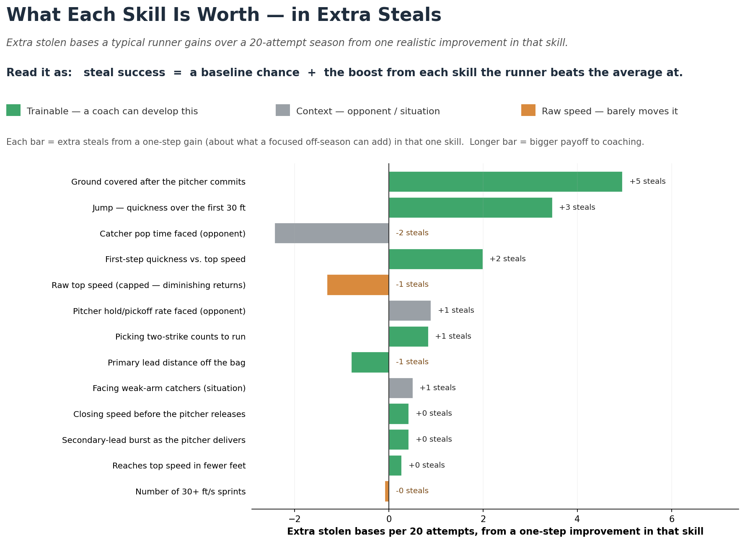
Figure 1 — Extra steals over a 20-attempt season from a one-step (a focused off-season's worth) improvement in each skill. Green = trainable, grey = opponent/situation, orange = raw speed. Longer bar = bigger coaching payoff.
Coachable lever | League  Avg | One-Step  Improvement | Added steals  (per 20 tries) | Effect
Ground covered after the pitcher commits | 52.20 | 2.92 | +5 | ↑ helps
Jump — quickness over the first 30 ft | 1.77 | 0.04 | +3 | ↑ helps
Catcher pop time faced (opponent) | 1.96 | 0.04 | -2 | ↓ hurts
First-step quickness vs. top speed | -1.41 | 18.95 | +2 | ↑ helps
Raw top speed (capped — diminishing returns) | 27.71 | 0.55 | -1 | ↓ hurts
Pitcher hold/pickoff rate faced (opponent) | 0.01 | 0.01 | +1 | ↑ helps
Picking two-strike counts to run | 0.86 | 0.21 | +1 | ↑ helps
Primary lead distance off the bag | 11.81 | 0.83 | -1 | ↓ hurts
Facing weak-arm catchers (situation) | 0.27 | 0.32 | +1 | ↑ helps
Table 1 — The nine biggest levers, in steals. "Added steals" = the extra stolen bases a runner gains over a 20-attempt season from one realistic improvement in that one skill. Read with Figure 1.

2 The Runners Who Already Have the Skill (Slow-Steal Skill)
What we did. We combined the skills above into one 'Slow-Steal Skill' score, tuned on 80% of the league with the benchmarks (Naylor, Soto) held out, then ranked every runner-season. Two columns are speed-adjusted — Ground Gained and Steals Above Speed-Expected — explained just below.
BOTTOM LINE The leaderboard is full of mid-pack-speed runners grading out elite — proof the trait is widespread and findable, not a one-player quirk.
Variables in this view:
- Player — Runner (and season).
- Top Speed — Sprint speed in feet/second — the structural baseline (Statcast).
- Jump (s) — Seconds to cover the first 30 ft. Lower = quicker first step. Coachable.
- Ground Gained — Feet of ground covered after the pitcher commits (first move → release). The biggest single driver of a steal.
- Steals Above Speed-Expected — How far the runner's success rate sits ABOVE the line speed alone predicts. Positive = beats his speed peers.
- SB / CS — Stolen bases / times caught stealing.
- Slow-Steal Skill — Overall technique score — skill beyond raw speed. Higher = better.
HOW WE STRIP SPEED OUT (so only skill is left)
Faster runners cover more ground and steal more — of course. To isolate skill we remove what speed alone explains: plot the skill against sprint speed, draw the line speed predicts, and keep only how far each runner sits ABOVE that line. "Ground Gained" and "Steals Above Speed-Expected" are that gap above the line — skill with speed stripped out.

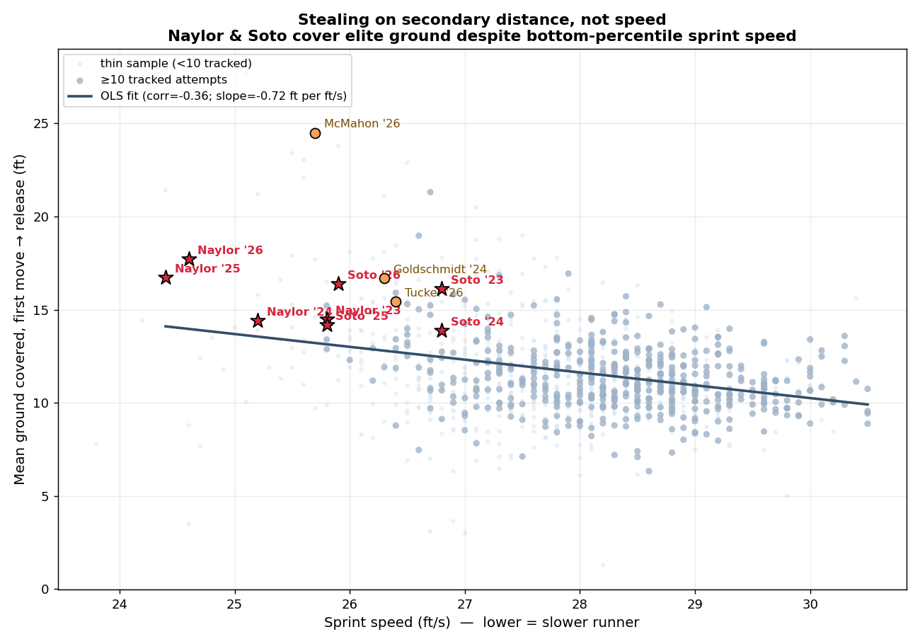
Figure 2 — Ground covered vs sprint speed. The line is what speed alone predicts; skill is the distance above it. Naylor, Soto, and McMahon sit far above the line at the slowest speeds — elite ground without elite wheels.
■ better than peers ■ league-average ■ worse than peers (shading = standard deviations above/below the players shown)
# | Player | Year | Top Speed  (ft/s) | Jump (s)  lower better | Ground Gained  (ft) | Steals Above  Speed-Expected | SB / CS | Slow-Steal  Skill
1 | Josh Naylor | 2025 | 24.4 | 1.87 | 41.5 | +12.2% | 30/2 | +1.85
2 | Josh Naylor | 2026 | 24.6 | 1.84 | 43.0 | +4.9% | 12/2 | +1.68
3 | Freddie Freeman | 2024 | 25.8 | 1.81 | 46.8 | +4.3% | 9/2 | +1.23
4 | Christian Vázquez | 2021 | 25.2 | 1.93 | 42.3 | -7.3% | 8/4 | +1.19
5 | Juan Soto | 2025 | 25.8 | 1.85 | 46.2 | +12.9% | 38/4 | +1.18
6 | Kyle Schwarber | 2025 | 25.9 | 1.79 | 47.0 | +5.6% | 10/2 | +1.15
7 | Miguel Rojas | 2024 | 25.8 | 1.88 | 44.5 | +3.0% | 8/2 | +1.12
8 | Kyle Tucker | 2024 | 26.0 | 1.80 | 46.9 | +17.1% | 11/0 | +1.11
9 | Manny Machado | 2024 | 25.8 | 1.86 | 46.0 | +6.5% | 11/2 | +1.09
10 | Alec Burleson | 2024 | 25.5 | 1.88 | 45.6 | -5.1% | 9/4 | +1.08
11 | Ryan McMahon | 2022 | 25.8 | 1.79 | 46.8 | -3.6% | 7/3 | +1.06
12 | Manny Machado | 2025 | 25.8 | 1.88 | 44.5 | +5.1% | 14/3 | +1.05
13 | Joc Pederson | 2024 | 25.5 | 1.83 | 45.8 | -8.6% | 7/4 | +1.04
14 | Josh Naylor | 2023 | 25.8 | 1.83 | 44.8 | +0.9% | 10/3 | +0.99
15 | TJ Friedl | 2024 | 26.5 | 1.77 | 49.8 | +10.4% | 9/1 | +0.90
Table 2 — Top 15 by Slow-Steal Skill (2015–2026). Top Speed is uncolored on purpose: speed is not what earns a spot. Amber rows flag the benchmarks (Naylor, Soto) — examples of the trait, held out while the score was tuned, not the basis of it.

2b The Full Leaderboard, Season by Season (with teams)
BOTTOM LINE The trait shows up every year and on every kind of team. Ryan McMahon's 2026 (Rockies) is the highest blueprint score in the data — a slow corner infielder out-converting the league's burners.
Blueprint score = the same speed-adjusted steal skill, scored 2023–2026 (higher = more skill beyond speed). Logos show each runner's team.
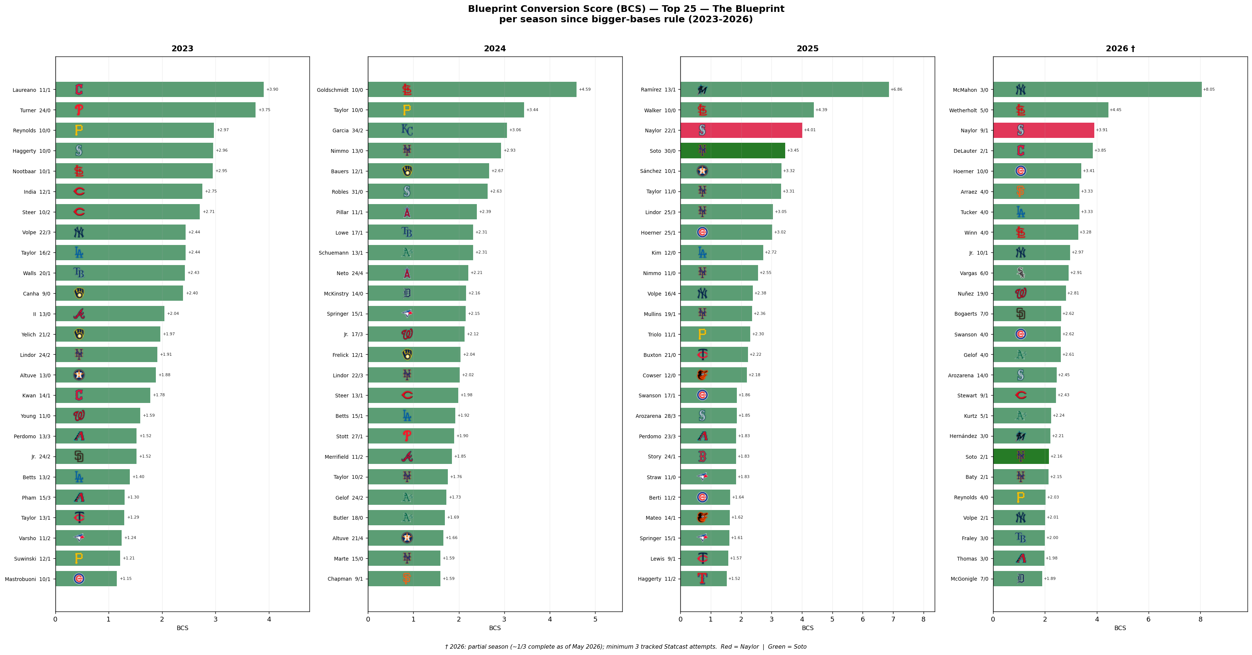
Figure 3 — Top 25 blueprint scores per season, 2023–2026 (2026 partial). Bars are speed-adjusted steal skill; gold = the slow-but-elite archetype, red = Naylor, green = Soto. Team logos mark each runner's club.

3 Who To Coach In 2025 — Targets and the Projected Prize
What we did. We plotted every qualified runner-season since 2023 by top speed (left→right) against steal production (down→up), then pulled the 2025 names into a target board with a projected payoff for each.
BOTTOM LINE Two clean opportunities fall out: fast, efficient runners who simply don't run enough (green-light them) and high-volume runners who get caught too often (fix the technique).
Variables in this view:
- Speed (SD) — Top speed expressed in standard deviations vs. the league (positive = faster).
- Steal Value (xSB) — z(net steals above avg) + z(top speed) — fast AND productive.
- Untapped Speed — Fast but under-stealing: z(top speed) − z(net steals). Higher = bigger coaching upside.
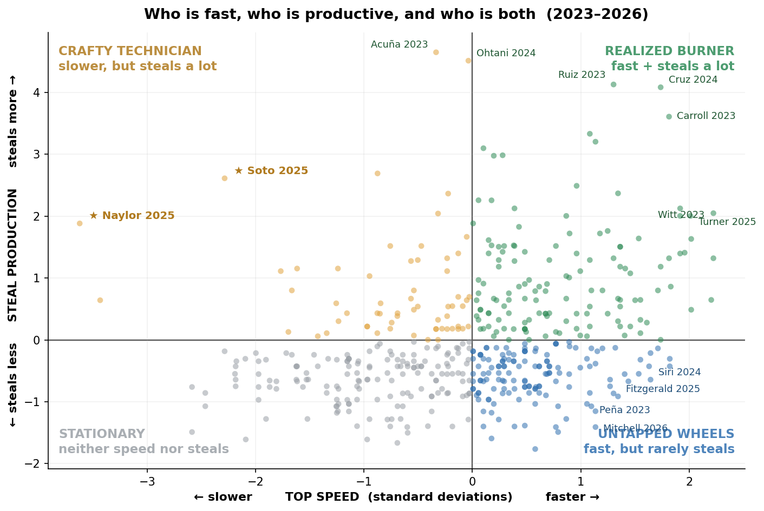
Figure 4 — Each dot is a runner-season (2023–2026). X-axis = top speed in standard deviations (right = faster); Y-axis = steal production (up = more). Green = fast & productive; blue (lower-right) = fast but under-stealing (the green-light targets); gold = the slow-but-productive archetype (★ Naylor, Soto); grey = neither. No red — no quadrant here is 'bad'.

3a Green-light targets — fast, efficient, under-running (just let them run)
What we did. We isolated the 2025 runners with top-third speed who already succeed at 80%+ but attempt fewer than ~20 steals, and projected the extra steals they'd add at a modest, speed-appropriate volume — kept at their own proven success rate.
BOTTOM LINE These are low-risk green-light decisions, not mechanics rebuilds: each already converts; they simply aren't running.
Variables in this view:
- Player — Runner (and season).
- Top Speed — Sprint speed in feet/second — the structural baseline (Statcast).
- SB / CS — Stolen bases / times caught stealing.
- Success rate — Share of steal attempts that succeed (SB ÷ attempts).
- Attempts — Stolen-base attempts this season (SB + CS).
- If unleashed — Projected extra net steals at a modest, speed-appropriate ~20-attempt volume, kept at the runner's own demonstrated success rate.
■ better than peers ■ league-average ■ worse than peers (shading = standard deviations above/below the players shown)
# | Player | Top Speed  (ft/s) | SB / CS | Success  rate | Attempts  (2025) | If unleashed  (+ steals)
1 | Nasim Nuñez | 29.8 | 9/1 | 86% | 10 | +7
2 | Eli White | 29.9 | 10/1 | 87% | 11 | +7
3 | Brandon Lockridge | 30.1 | 10/1 | 87% | 11 | +7
4 | Marcus Semien | 28.5 | 11/1 | 88% | 12 | +6
5 | Hyeseong Kim | 28.7 | 13/1 | 89% | 14 | +5
6 | Ezequiel Duran | 28.8 | 11/2 | 83% | 13 | +5
7 | Myles Straw | 29.4 | 12/1 | 88% | 13 | +5
8 | Tyrone Taylor | 29.3 | 12/2 | 84% | 14 | +4
Table 3 — 2025 green-light board. "If unleashed" = projected extra net steals at ~20 attempts, at the runner's own 2025 success rate (illustrative, not a forecast of behavior).

3b Technique-fix targets — high volume, caught too often (drill the weakest lever)
What we did. The opposite group: 2025 runners attempting a lot (12+) but converting below 70%. For each we name the trainable skill where they are furthest below average and the success-rate gain from lifting it to league average.
BOTTOM LINE These should not run more — they should run better. The fix is mechanics, and the model says which one.
Variables in this view:
- Player — Runner (and season).
- Top Speed — Sprint speed in feet/second — the structural baseline (Statcast).
- SB / CS — Stolen bases / times caught stealing.
- Success rate — Share of steal attempts that succeed (SB ÷ attempts).
- Weakest lever — The trainable skill where this runner is furthest below league average.
- Projected fix — Success-rate gain if that weakest lever is lifted to the league average.
Player | Top Speed  (ft/s) | SB / CS | Success  rate | Attempts  (2025) | Weakest  lever | Fix →  + steals/20
Tyler Freeman | 28.5 | 18/9 | 68% | 27 | Secondary-lead burst | —
Jacob Young | 29.3 | 15/11 | 61% | 26 | First-step burst | +5
James Wood | 27.8 | 15/7 | 70% | 22 | Secondary-lead burst | +1
Andy Pages | 28.1 | 14/7 | 69% | 21 | First-step burst | +3
Harrison Bader | 28.8 | 11/7 | 65% | 18 | Secondary-lead burst | +1
Luis Rengifo | 27.0 | 10/7 | 63% | 17 | Ground covered | +7
Table 4 — 2025 technique-fix board. "Fix → + steals/20" = the extra steals a runner would gain over 20 tries if his weakest skill were raised to league average. Red success rate = caught too often today; that's the opportunity.

4 What To Coach — Three Priorities, and the Caveats
Section 1 names three trainable skills. Each is technique, not body type — which is why a slow runner can lead the league in steal skill. The payoff below is straight off Table 1.
- Cover more ground once the pitcher commits. (+5 steals / 20 tries) The single biggest lever. Train the secondary-lead explosion and the read of the pitcher's first move — distance gained before the throw is worth more than raw foot speed.
- Sharpen the jump. (+3 steals / 20 tries) Cutting the time to the first 30 feet is pure technique — stance, weight shift, and first-step direction, not body type.
- Reach top speed sooner. (+2 steals / 20 tries) Runners who hit top gear in fewer feet steal above their speed peers. Acceleration mechanics, not a higher top speed, are what convert.
Net play: green-light the Table-3 names, drill the Table-4 names on the lever listed, and you convert latent speed and wasted attempts into runs — without touching anyone's physical ceiling.

Read the projections honestly
- The target boards are estimates, not forecasts. "If unleashed" holds a runner at his own 2025 success rate and a modest ~20-attempt volume; real results depend on health, matchups, and game situation. Treat the steal projections as a priority ranking — not a guarantee.
- Per-lever gains assume the rest stays equal. A +1-SD improvement is real but ambitious, and the model holds the other skills fixed. Small, compounding gains across two levers are more realistic than a single full-SD jump.
- Context columns are not coaching levers. Catcher pop time and pitcher hold rate move success in the math, but you don't coach them — they're shown so you can separate skill from circumstance.

Metric Reference — flip here anytime
Plain-English definition of every metric used above. You don't need this to read the report — each section already defines the variables it uses — but it's here if you want to dig into a specific number.
Slow-Steal Skill (SSSI) | Overall technique score — how good a runner is beyond what raw speed explains. Higher = more skill.
Top Speed | Sprint speed in feet/second (Statcast). The structural baseline a runner is born with.
Jump | Seconds to cover the first 30 ft. Lower = quicker first step. Coachable.
First-Step Burst | Reaches top speed in fewer feet than his speed predicts. A premium when paired with high speed.
Steals Above Speed-Expected | Real success rate minus the rate his sprint speed alone would predict. Positive = beats his speed peers.
Steal Value (xSB) | Speed AND production combined: z(net steals above avg) + z(top speed). Surfaces fast, high-volume burners.
Untapped Speed | Fast but under-stealing — z(top speed) minus z(net steals). The clearest coaching targets.

